**For Deploying Java Web Application in Amazon Ec2 using Eclipse**

Lab-2 A-Configuration of aws with eclipse

Step1-First you have to install the AWS toolkit for eclipse plugin

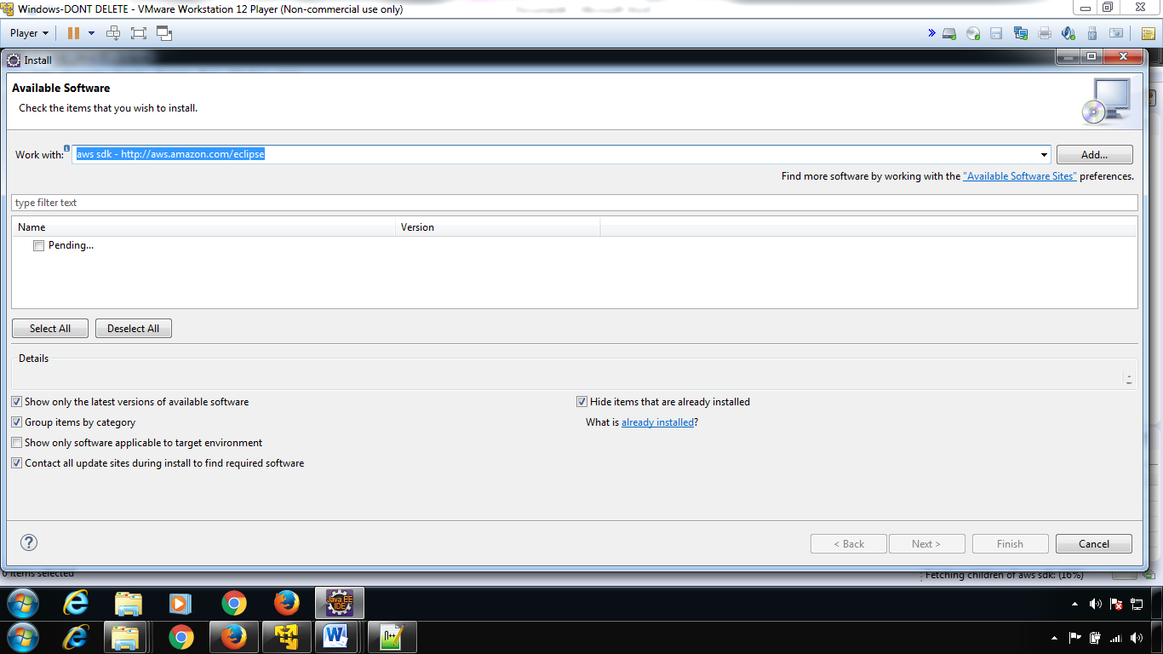

Step-2: creating a new access key( to get secrect access key)----By default---No secret access key

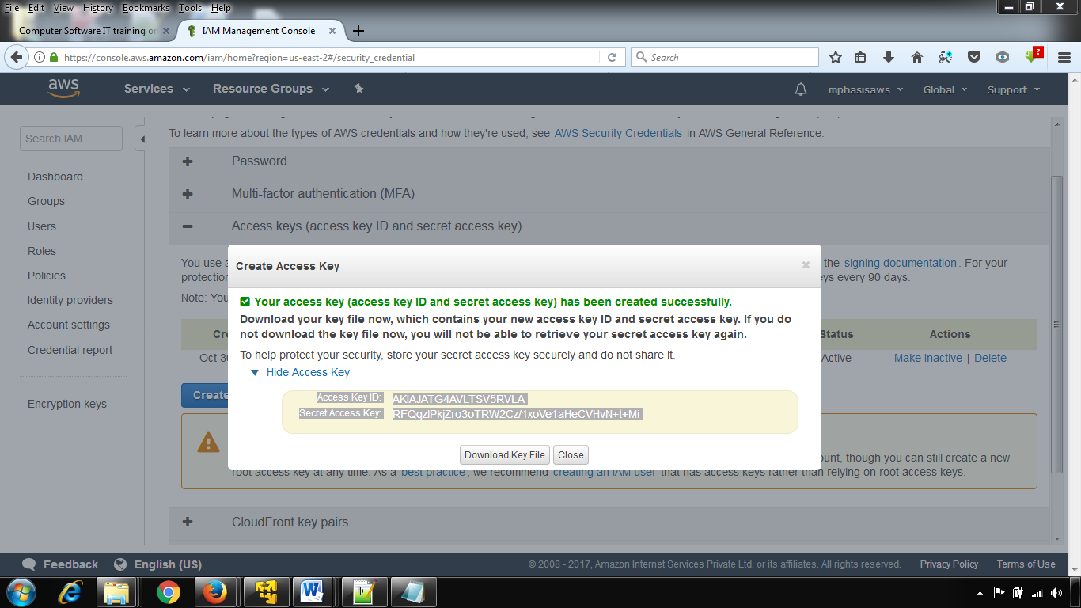

Step-2

* Windows --> Preferences --> select AWS Toolkit and Fill the fields according to your amazon ec2 account
* Give your name to Account Name (Not Necessary), 3 inputs---acesskey+secret accesskey+account id
* In the optional configuration (Expand it) give account id (exact value) to that field
* 3 inputs---acesskey+secret accesskey+account id

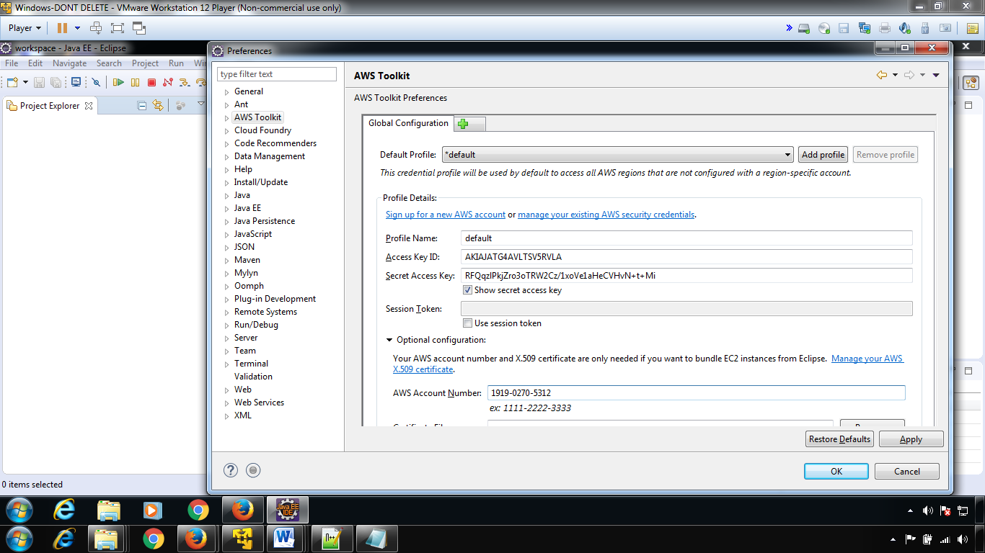

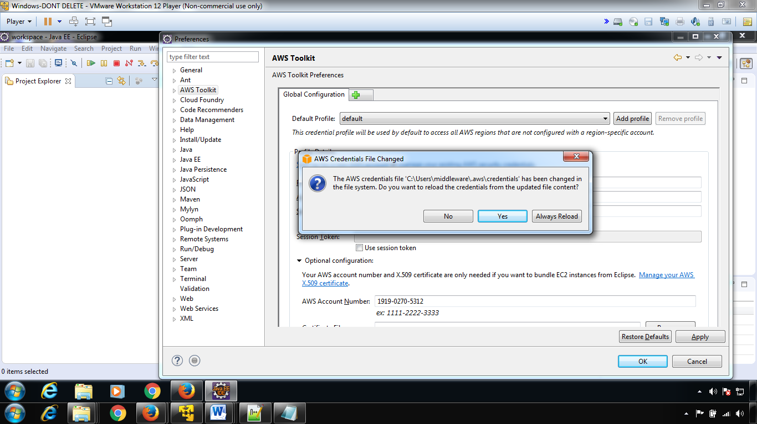

Click OK

**Step 4**

* Windows --> Show view --> Other --> Select AWS toolkit view (Select all views) --> OK
* Now you can see the perspective view of aws.

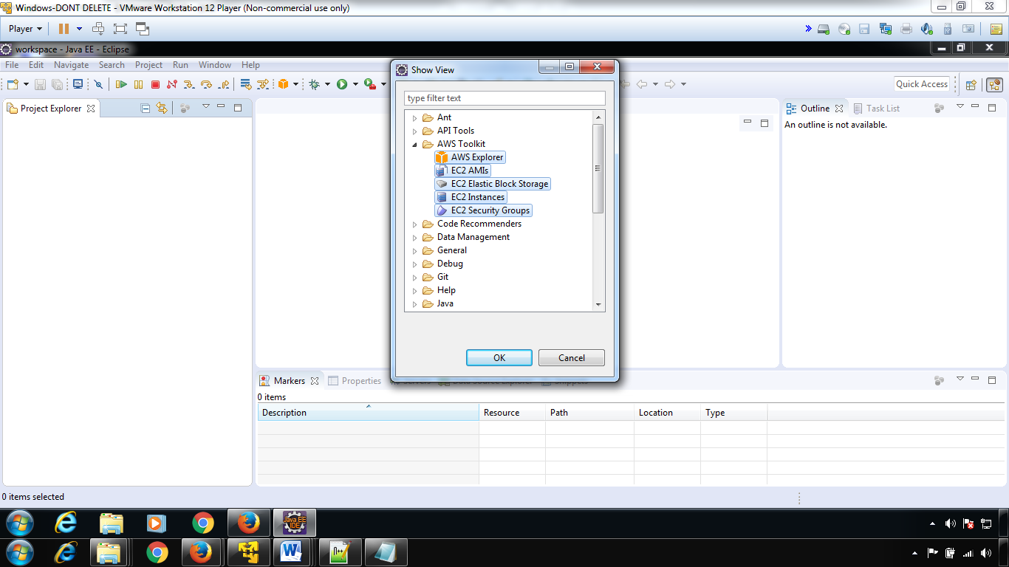

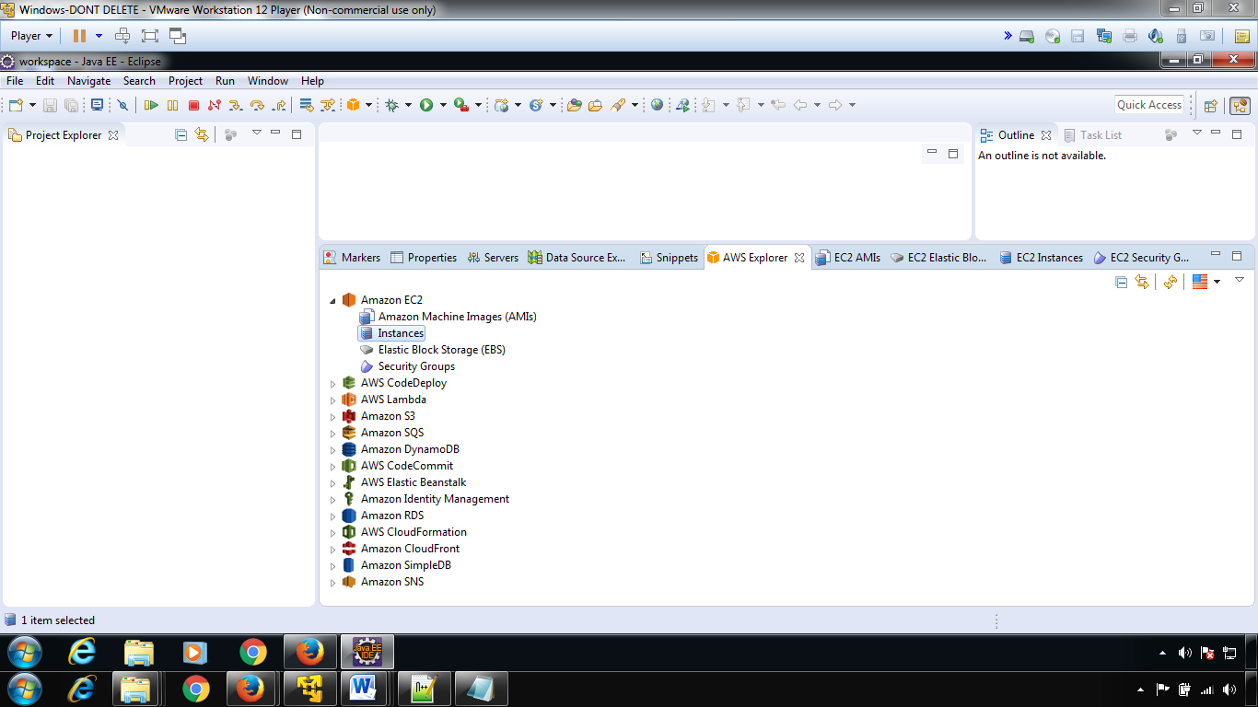

Configuration of aws with eclipse-done